**Assignment 7.2**

**Problem Statement :**

"We have a dataset of sales of different TV sets across different locations. Records look like: Samsung|Optima|14|Madhya Pradesh|132401|14200 The fields are arranged like : Company Name|Product Name|Size in inches|State|Pin Code|Price Sales_TV : https://github.com/prateekATacadgild/DatasetsForCognizant/blob/master/sales_differentTV.tx t Sales of different TV

**Task 6 : Modify Sales of different TV Task 3 (refer session 5, assignment 2) to take advantage of Combiner. Sales of different TV**

**Program :**

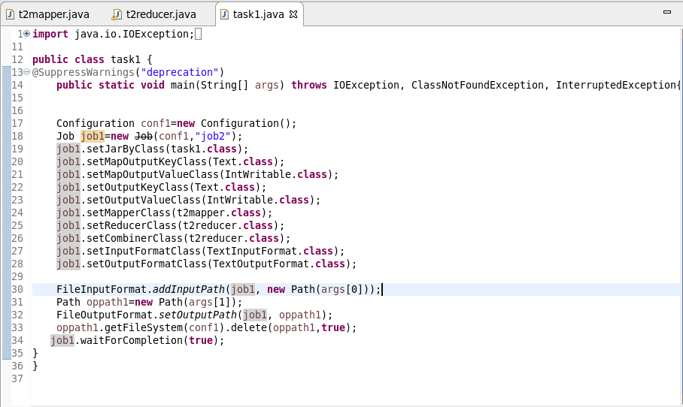

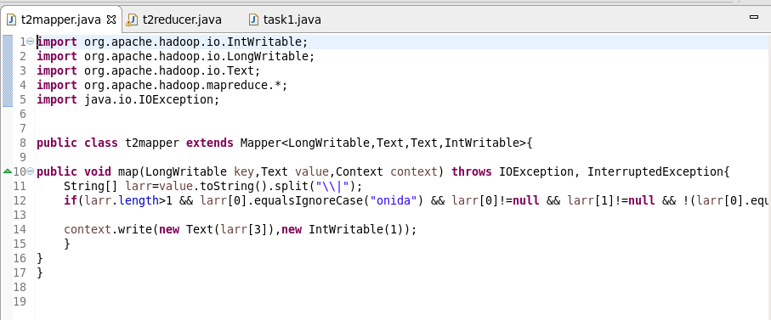

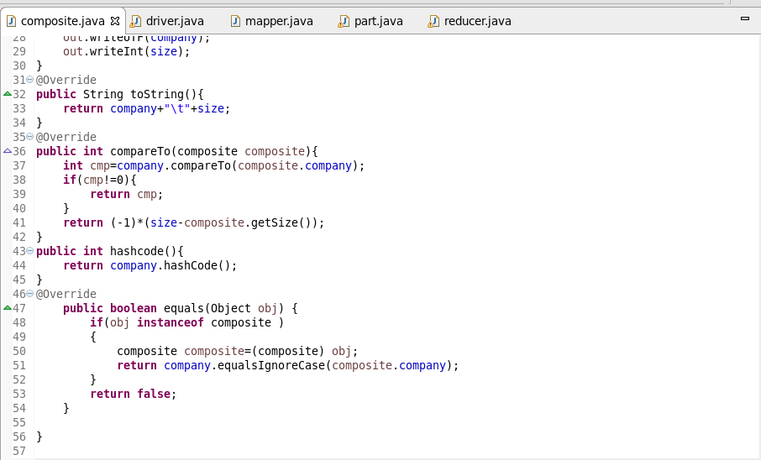

**Output :**

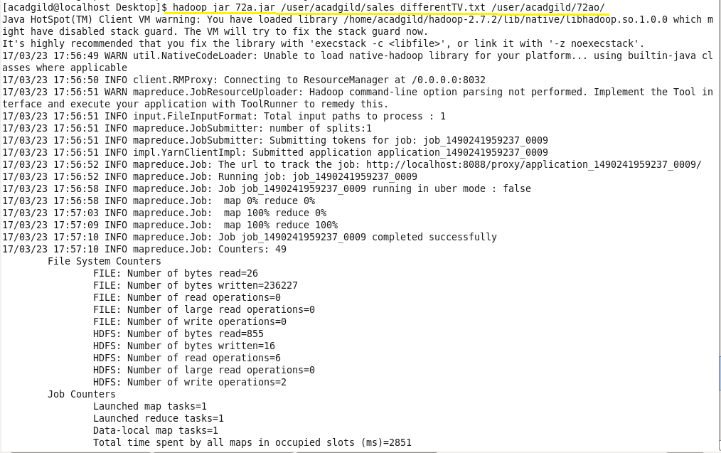

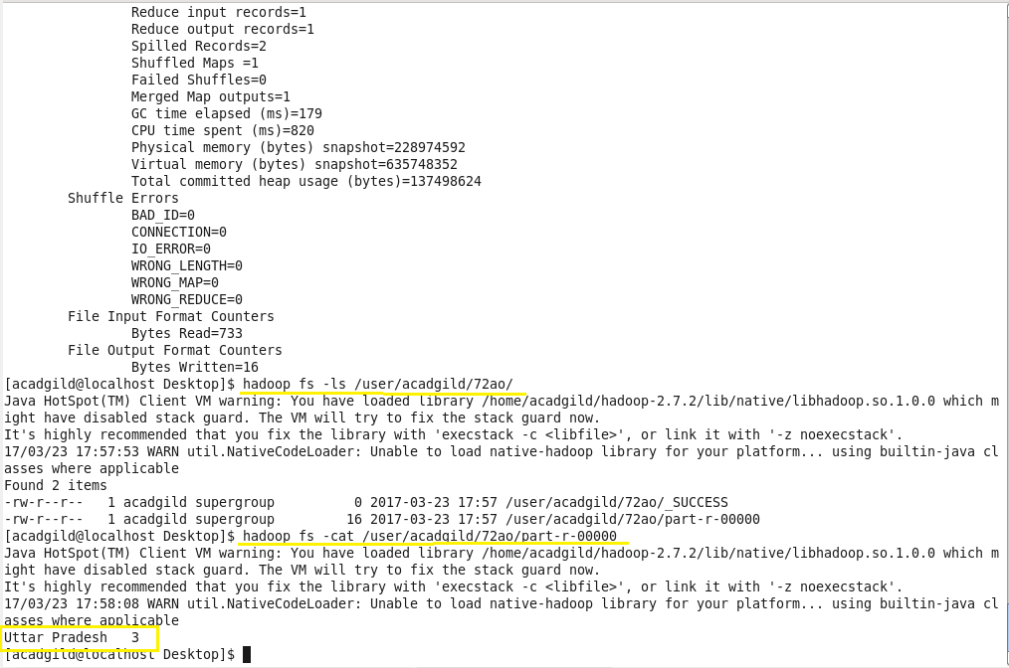

**Task 7 : Write a Mapreduce program to view the total sales for each product for every Company corresponding to each size. Make sure that all records for a single company goes to a single reducer and inside every reducer, keys must be sorted in descending order of the size. You may write a custom WritableComparable for this purpose. "**

**Program :**

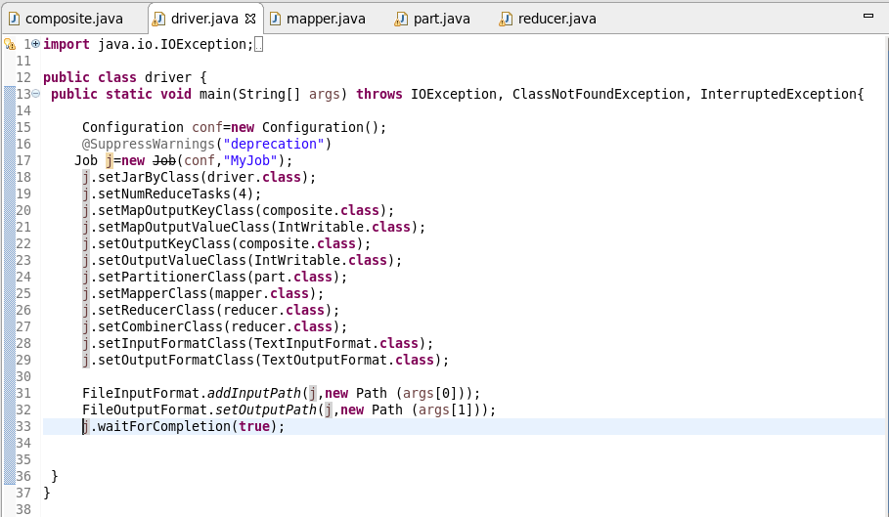

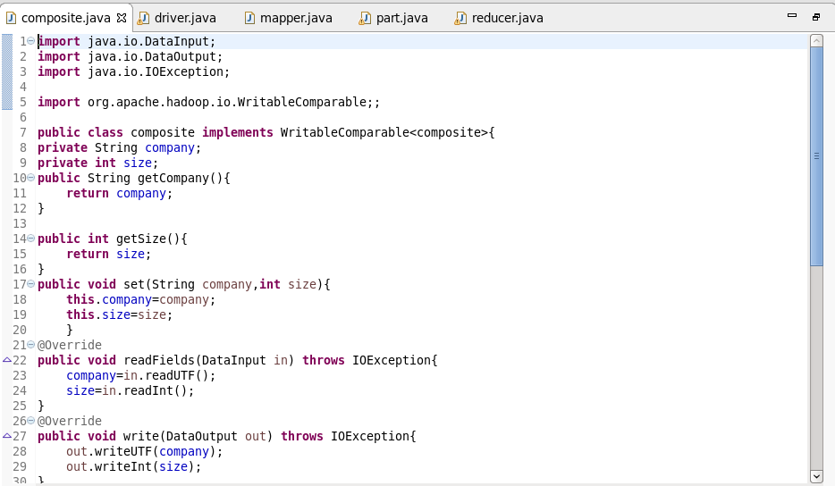



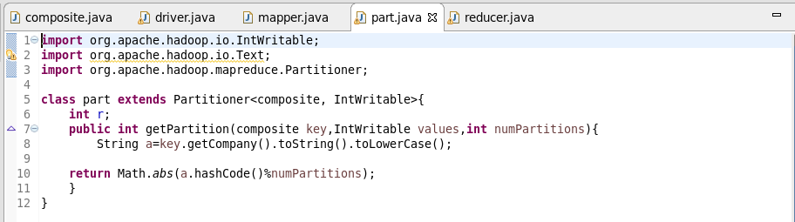

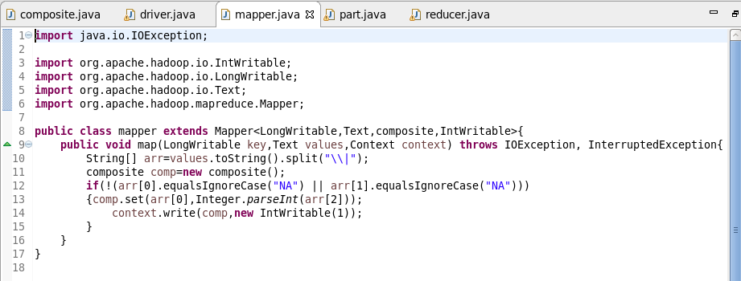

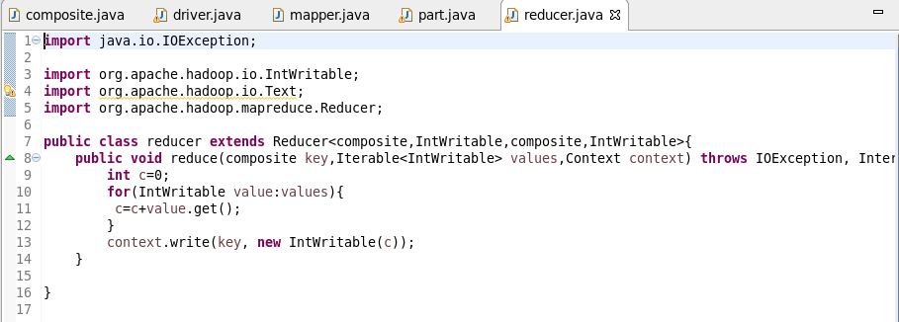

**Output :**

